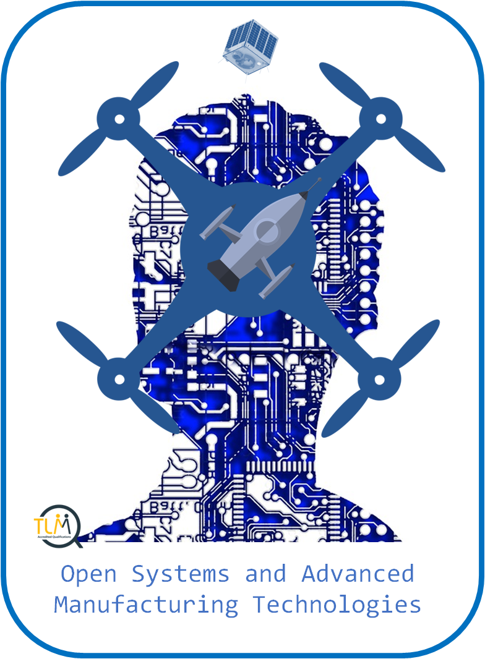
Open Systems and Advanced Manufacturing Technologies

  - Unit 2 – The Understanding and Application of Microsatellites:

Name: __________________________

  - Coursework evidence folder
Contents
SECTION 1 – Candidates should be able to demonstrate they understand the range of microsatellite use. 5
Coursework Evidence 1.2 5
Candidates should be able to show they understand the basic differences between the main microsatellites. 5
Coursework Evidence 1.4 5
SECTION 2 – Candidates should be able to describe a number of launch vehicles. 5
Coursework Evidence 1.3 5
Coursework Evidence 1.1, 1.5 6
SECTION 3 – Candidates should be able to show they understand the implications of size and weight on the success of satellite technology 6
Coursework Evidence 2.1 6
SECTION 4 – Candidates should be able to list and describe a number of the main construction materials used, giving reasons for their choice. Candidates should be able to show they understand the basic forces that satellites need to endure. 7
Coursework Evidence 2.2 7
Coursework Evidence 2.3 7
SECTION 5 – Candidates should be able to show they understand the ways that engineers control their devices 7
Coursework Evidence 2.4 7
SECTION 6 – Candidates should be able to use their knowledge and understanding to put together a simple shopping list of requirements. Candidates should be able to construct a basic diagram of their microsatellite with labels for key components. 7
Coursework Evidence 2.5 7
Coursework Evidence 2.6 8
SECTION 7 – Candidates should be able to show they understand the relationships between weight and size and cost of deployment. Candidates should be able to show they understand some key terms used and show their understanding with clear examples 8
Coursework Evidence 3.1, 3.2 8
SECTION 8 – Candidates should be able to document some of the propellants used in satellites and their characteristics. Candidates should be able to show they understand some of the characteristics of propellants. 8
Coursework Evidence 3.3, 3.4 8
SECTION 9 – Candidates should be able to show they understand the different orbits in terms of their distance and characteristics. 9
Coursework Evidence 3.5 9
SECTION 10 – Candidates should be able to show they understand some legal issues 9
Coursework Evidence 3.6 9
SECTION 11 – Candidates should 9
Coursework Evidence 4.1 – 4.5 9

Coursework Checklists

- 1. Understand the current place in the market of microsatellites |  | - 2. Review and define the key issues in making a microsatellite |  | - 3. Understand the key issues in space deployment |  | - 4. Investigate the control, data use and end of life issues related to microsatellites
Section 1 – Microsatellite Types (1.4) Microsatellite use (1.2) |  | Section 3 – Microsatellite size (2.1) |  | Section 7 – Cost to deploy (3.1, 3.2) |  | Section 11 –
Section 2 – Launch Vehicles (1.1, 1.3 and 1.5) |  | Section 4 – Microsatellites and materials (2.2, 2,3) |  | Section 8 – Propellants (3.3, 3.4) |  | Section 12 –
 |  | Section 5 – Communications (2.4) |  | Section 9 – Orbits (3.5) |  | Section 13 –
 |  | Section 6 – Design own microsatellite (2.5, 2.6) |  | Section 10 – Legal Issues (3.6) |  | Section 14 –
 |  |  |  |  |  | Section 15 –

SECTION 1 – Candidates should be able to demonstrate they understand the range of microsatellite use.

Coursework Evidence 1.2
Complete the table below describing the different uses for microsatellites
- Microsatellite Uses | - Description of use including exmples and images
GPS
Weather
University Use
Maps

Candidates should be able to show they understand the basic differences between the main microsatellites.

Coursework Evidence 1.4
Complete the table below describing the different types of microsatellites.
- Microsatellite Versions | - Description including characteristics and images
Nanosatellites
Picosatellites
Femtosatellites

SECTION 2 – Candidates should be able to describe a number of launch vehicles.

Coursework Evidence 1.3
Use the space below to describe how microsatellites are launched – remember to show a range of vehicles used.

Candidates should be able to show they understand the most current state of the market for microsatellites. Candidates should be able to show they can appreciate the reasons behind some of the market information.

Coursework Evidence 1.1, 1.5
Use the space below to describe the main countries involved in launching microsatellites, the history and future of microsatellites, cost changes and the setbacks

SECTION 3 – Candidates should be able to show they understand the implications of size and weight on the success of satellite technology

Coursework Evidence 2.1
Use the table below to show the implications of the paper helicopter tests on weight and thrust
- Weight – Number of paperclips | - What happened? How much thrust did you need? – air from hairdryer etc?

  - What has this test shown you?

SECTION 4 – Candidates should be able to list and describe a number of the main construction materials used, giving reasons for their choice. Candidates should be able to show they understand the basic forces that satellites need to endure.

Coursework Evidence 2.2
Use the space below to describe the materials used in the building of a microsatellite and why they are used – link this to the atmosphere, temperature, radiation etc

Coursework Evidence 2.3
Use the space below to add your diagram of the lifecycle of a microsatellite and describe the forces that are in affect against the microsatellite at each stage and how this has to be considered in construction

SECTION 5 – Candidates should be able to show they understand the ways that engineers control their devices

Coursework Evidence 2.4
Use the space below to describe the main forms of communication and examples of how they are used – using details of distance, temperature being close to the sun, volume of data etc

SECTION 6 – Candidates should be able to use their knowledge and understanding to put together a simple shopping list of requirements. Candidates should be able to construct a basic diagram of their microsatellite with labels for key components.

Coursework Evidence 2.5
Use the space below to show your list of requirements needed for your microsatellite
- Purpose of Microsatellite | - Materials needed | - Communication devices/types

Coursework Evidence 2.6
Use the space below to show your microsatellite design with clear labels of the main parts

SECTION 7 – Candidates should be able to show they understand the relationships between weight and size and cost of deployment. Candidates should be able to show they understand some key terms used and show their understanding with clear examples

Coursework Evidence 3.1, 3.2
You have been asked to provide valuable research to a new company that wish to launch a weather microsatellite and need to understand the costs that this entails. Use the space below to write your detailed report on the costs that they might face – thinking about the weight and size etc.
You also need to describe the term ‘piggyback’ in relation to deployment of a microsatellite as this may be an option to this new company to deploy their microsatellite for weather.

SECTION 8 – Candidates should be able to document some of the propellants used in satellites and their characteristics. Candidates should be able to show they understand some of the characteristics of propellants.

Coursework Evidence 3.3, 3.4
Complete the table below defining the main propellants and their uses and describing the strengths and weaknesses of each
- Propellant | - Usage | - Strengths | - Weaknesses
Anhydrous Hydrazine
Monomethyl Hydrazine
ALICE

SECTION 9 – Candidates should be able to show they understand the different orbits in terms of their distance and characteristics.

Coursework Evidence 3.5
Use the space below to describe the different levels of orbit used by microsatellites and ensure detailed and using diagrams to show understanding.

SECTION 10 – Candidates should be able to show they understand some legal issues

Coursework Evidence 3.6
Use the space below to describe the different legal issues that relate to microsatellites

SECTION 11 – Candidates should

Coursework Evidence 4.1 – 4.5
The company that are going to launch a weather microsatellite are also looking for some more information and need you to research and describe the following points:
- How can the microsatellite be controlled from earth? What are out options?
- How can we control the microsatellite in space? What are our options?
- What dangers should we consider for our microsatellite in space and returning to earth?
- What do you think is the future of microsatellites and how they could be used?

