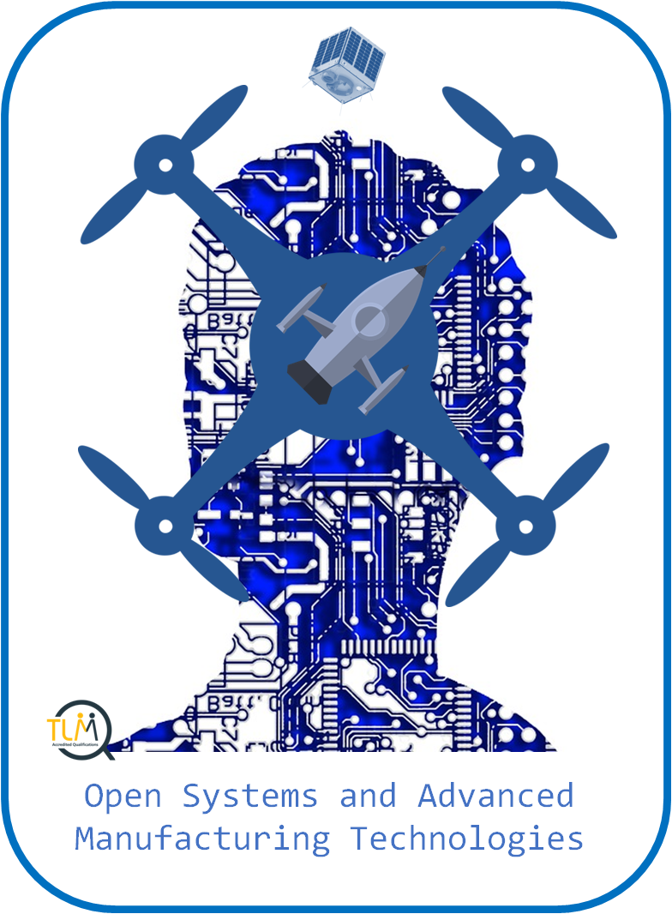
Open Systems and Advanced Manufacturing Technologies

  - Unit 3 – Working with Robotics and Artificial Intelligence:

Name: __________________________

  - Coursework evidence folder
Contents
SECTION 1 – Candidates should be able to show they understand the basic aspects of AI. 4
Coursework Evidence 1.1 4
SECTION 2 – Candidates should be able to describe, perhaps by creating a table, the main uses of AI. Candidates should be able to give some clear details of their chosen examples from 1.2. 5
Coursework Evidence 1.2, 1.3 5
SECTION 3 – Candidates should be able to demonstrate a broad understanding of using AI. Candidates should be able to demonstrate an appreciation for some of the good and bad aspects of using AI. Candidates should be able to describe the legal and ethical concerns. 6
Coursework Evidence 1.4, 1.5, 1.6 6
SECTION 4 – Candidates should be able to list, with guidance, the main industrial applications of robotics. 7
Coursework Evidence 2.1 7
SECTION 5 – Candidates should be able to give some examples in their own words of robots used in medicine. 7
Coursework Evidence 2.2 7
SECTION 6 – Candidates should be able to list, with guidance, the agricultural application and use of robotics. 7
Coursework Evidence 2.3 7
SECTION 7 – Candidates should be able to show other areas of robotics use. Candidates should be able to show that they understand some of the dangers of using and being reliant on robots. 8
Coursework Evidence 2.4 8
Coursework Evidence 2.5 8
SECTION 8 – Candidates should be able to show familiarity with some of the tools available to create robots. Candidates should be comfortable around the various tools used to design and create robots. 8
Coursework Evidence 3.1, 3.2 8
SECTION 9 – Candidates should be able to understand the main components and separate parts of a robotic device. Candidates should be able to participate in building a basic robot system. 9
Coursework Evidence 3.3, 3.4 9
SECTION 10 – Candidates should be able to appreciate quality control issues in engineering. Candidates should be able to appreciate some of the main features of hardware and software used in robotic products. 9
Coursework Evidence 4.1, 4.2 9
SECTION 11 – Candidates should be able to list a number of basic changes to a design. Candidates should be able to identify possible improvements. 10
Coursework Evidence 4.3 10
Coursework Evidence 4.4 10

Coursework Checklists

1. Understand what Artificial Intelligence is and how it works |  | 2. Review and define examples of where robotics is used |  | 3. Understand the processes of making a basic robot work |  | 4. Appreciate and test the issues and challenges of robotics
Section 1 – List Features of AI (1.1) |  | Section 4 – Describe Industrial use of AI (2.1) |  | Section 8 – Review and assess tools available to build robots (3.1, 3.2) |  | Section 10 – Test build quality, hardware and software
Section 2 – Describe main uses and review expectations (1.2, 1.3) |  | Section 5 – Review Medical use of AI (2.2) |  | Section 9 – Components and build a basic robot (3.3, 3.4) |  | Section 11 – Robotic package improvements and recommend additional features to a piece of technology design
Section 3 – Future use, strengths and weaknesses and describe legal and ethical implications (1.4, 1.5, 1.6) |  | Section 6 – Describe Agricultural use of AI (2.3)
 |  | Section 7 – Wider use of AI and the possible dangers of using AI (2.4, 2.5)

SECTION 1 – Candidates should be able to show they understand the basic aspects of AI.

Coursework Evidence 1.1
Artificial Intelligence is a computer device that can carry out a task normally completed by a human as it can use specific aspects to complete a task and to do this the idea of intelligence needs to be defined. Use the space below to mind map the 10 x aspects of intelligence in AI:

SECTION 2 – Candidates should be able to describe, perhaps by creating a table, the main uses of AI. Candidates should be able to give some clear details of their chosen examples from 1.2.

Coursework Evidence 1.2, 1.3
Complete the table below describing the different uses of artificial intelligence
Choose one of the areas above and describe the main uses in the AI in this sector and what is expected from the AI uses, using clear examples.
- AI Use | - Description how artificial intelligence is used within this area
Computer Science,
Aviation,
Education,
Finance,
Heavy Industry,
Hospitals and Medicine,
Human Resources and Recruiting,
Marketing,
Music,
News,
Publishing and Writing,
Online and Telephone Customer Service,
Telecommunications Maintenance,
Toys and Games,
Transportation.

Chosen area to research | What examples of AI usage can be found in this sector and what is expected from the companies when AI is created?

SECTION 3 – Candidates should be able to demonstrate a broad understanding of using AI. Candidates should be able to demonstrate an appreciation for some of the good and bad aspects of using AI. Candidates should be able to describe the legal and ethical concerns.

Coursework Evidence 1.4, 1.5, 1.6
Using the table below and document from research the intended uses for AI in the future,
- Intended Use | - Review would you have researched

  - What are the strengths and weaknesses of using Artificial Intelligence
Strengths
Weaknesses

  - DESCRIBE the legal and ethical concerns when creating AI
Legal
Ethical

SECTION 4 – Candidates should be able to list, with guidance, the main industrial applications of robotics.

Coursework Evidence 2.1
Use the space below to describe the main industrial applications of robotics

SECTION 5 – Candidates should be able to give some examples in their own words of robots used in medicine.

Coursework Evidence 2.2
Use the space below to review the main medical applications of robotics

SECTION 6 – Candidates should be able to list, with guidance, the agricultural application and use of robotics.

Coursework Evidence 2.3
Use the space below to describe the main Agricultural applications of robotics

SECTION 7 – Candidates should be able to show other areas of robotics use. Candidates should be able to show that they understand some of the dangers of using and being reliant on robots.

Coursework Evidence 2.4
You have been asked to look at different areas robotics are used and need to look at a wider area, for example how are robotics used in space? Assess the wider use of robotics in space below:

Coursework Evidence 2.5
Using the space below discuss the dangers of being reliant on Artificial Intelligence and Robotics in today’s society

SECTION 8 – Candidates should be able to show familiarity with some of the tools available to create robots. Candidates should be comfortable around the various tools used to design and create robots.

Coursework Evidence 3.1, 3.2
Using the table below identify some software and hardware options available to build a robot and the good and bad points of them.
- Software Options | - Good and Bad Points | - Hardware | - Good and Bad Points

SECTION 9 – Candidates should be able to understand the main components and separate parts of a robotic device. Candidates should be able to participate in building a basic robot system.

Coursework Evidence 3.3, 3.4
Use the space below to add a picture of the robot you have built and outline the component choices you made when building

SECTION 10 – Candidates should be able to appreciate quality control issues in engineering. Candidates should be able to appreciate some of the main features of hardware and software used in robotic products.

Coursework Evidence 4.1, 4.2
Use the testing table below to test the build quality, hardware and software
What are you testing? | What is expected to happen? | What actually happened? | Analysis

SECTION 11 – Candidates should be able to list a number of basic changes to a design. Candidates should be able to identify possible improvements.

Coursework Evidence 4.3
Use the space below to outline the improvements that could be made to the robot package used

Coursework Evidence 4.4
Use this space to look at one piece of technology design and recommend additional features to help improve it

