Forces and Flight
  - Starter - What can fly? Add to the mind map below

  - Section 1
The bigger the downward blast of __________, the bigger the _________ (thrust) pushing the rocket ___________.
Thrust comes from ……..
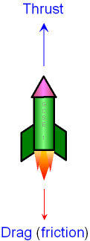
What is forced downwards and pushes the rocket upwards?:

  - Section 2 - complete the table describing each key term

Gravity
Thrust
Air Resistance
Weight

  - Section 3 – What are the 3 Laws of Newton’s Law of Motion

1st LAW
2ND LAW
3RD LAW

