Forces
Rocket science includes ideas of forces and motion, how rockets work and some of the challenges for those wanting to make rockets go faster and higher.
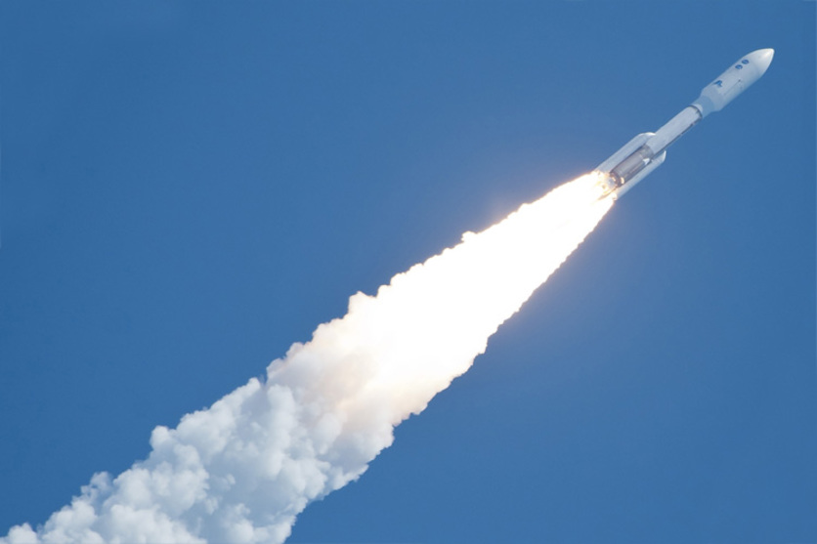
Juno launch
This Atlas V rocket carried the Juno spacecraft in the top payload section. Liftoff was on 5 August 2011. It took 5 years to travel the 2,800 million kilometres to reach Jupiter.
In the last 60 years, rocket science and technology has certainly reached new heights. Many rockets have been used to explore our atmosphere and to travel further from the Earth to explore the Moon, Venus, Mars and other parts of the Solar System and beyond. Other rockets are used to launch the many satellites that we rely on for weather forecasting and communication. Rockets are also used for fireworks and entertainment.
  - Rocket science and design challenges
The science of forces and motion began to be properly understood when Sir Isaac Newton wrote a book called Principia over 200 years ago. This contained his three laws of motion and paved the way for people to understand how rockets work. Before this time, a lot of people thought rockets needed air to push against. It turns out they don’t! Rockets work even better in the vacuum of space than they do in the Earth’s atmosphere.
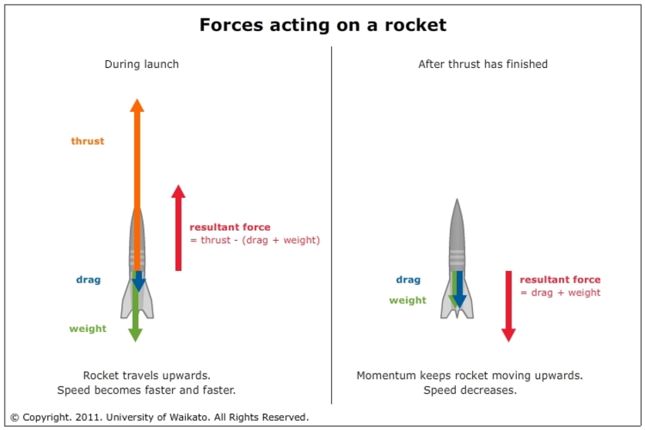
Rocket forces
A rocket has three main forces acting on it during lift-off. The resultant force is the sum of these. The rocket will speed up (or slow down) in the direction of the resultant force.
Rocket design is all about finding an optimal balance between thrustmass and aerodynamics. Any change to one of these will affect the overall motion of the rocket:
- Thrust is the force that pushes a rocket. There are many types of rocket engines that use different propellants. Find out more in the article Rockets and thrust.
- A rocket has mass as payload and propellant, but with each extra bit of mass, there is extra gravity that requires extra thrust.
- Aerodynamics is the study of how air flows over a rocket. Aerodynamics only affects a rocket while it is in an atmosphere. Find out how a nose cone and fins help a rocket in the article Rocket aerodynamics.

Rockets and Thrust
What is a rocket pushing against to make it start moving? Is it pushing against the ground? The air? The flames?
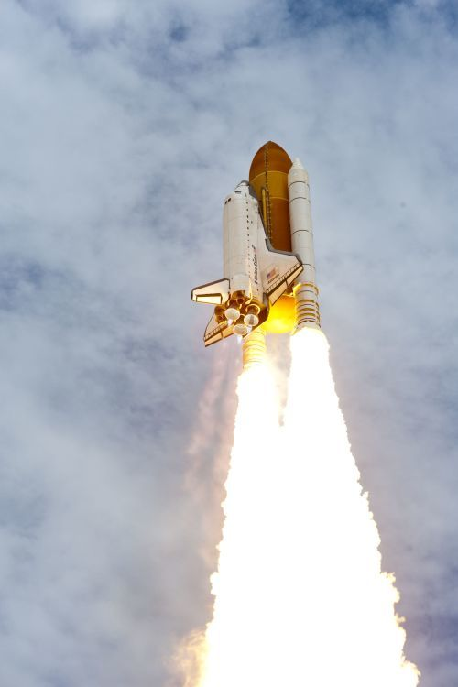
Space Shuttle launch
Final launch of Space Shuttle Atlantis on July 8 2011. The two solid rocket boosters produce most of the thrust, but also notice the faint blue flames from the three main engines at the tail of the orbiter
To make any object start moving, something needs to push against something else. When you walk, you are pushing against the ground, so the ground pushes back against you to make you start to move. A plane uses its propellers to push air backwards, so the air pushes back against the plane to make it start moving.
In the same way, a rocket needs to push against something. It is pushing against the gases inside it. As these gases are pushed out in one direction, there is a reaction force that pushes the rocket in the other direction. This reaction force is called thrust.
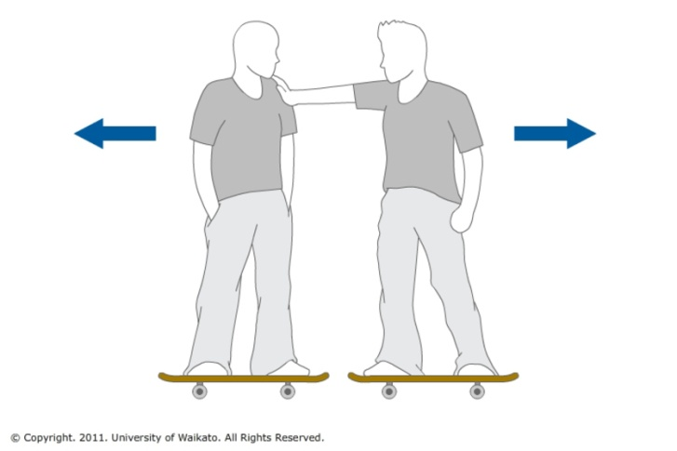
  - Rocket science on a skateboard
To understand this idea, it is useful to think of two people standing next to each other on skateboards. If one person pushes the other person, each person will be pushed in opposite directions. Both people will move.
Skateboard forces
Forces always come in pairs. If one person on a skateboard pushes another person, both skateboarders are pushed apart with equal but opposite forces
If you are on a skateboard by yourself, you could still make yourself move by throwing off a heavy object in one direction. This would push you and the skateboard in the opposite direction. To produce more thrust, you could throw something off your skateboard with more speed.
A rocket works in a very similar way. It throws out tiny bits of mass at high speeds to push the rocket in the opposite direction.
  - Newton’s third law
Newton’s third law explains how rocket produce thrust – for every force pushing on one object, there is an equal but opposite force pushing on another object.
Another way of saying this is that, for every action, there is an equal and opposite reaction. Forces always come in pairs.
A rocket pushes gases (or liquid) from inside it in one direction, and this pushes the rocket in the opposite direction. If the mass is thrown out at faster speeds, there will be more force pushing the rocket.
  - Canister rockets, balloon cars and water rockets
A film canister rocket uses a chemical reaction to build up gas pressure inside the canister. When the pressure is high enough, the lid pops off. The gases inside the rocket are pushed downwards so the canister rocket is pushed upwards.
For a balloon-powered toy car, the pressure inside the balloon pushes the gases in one direction, so the toy car is pushed forwards in the opposite direction.
A water rocket has air inside a plastic bottle with some water added. More air is pumped into the bottle to build up the pressure. When the rocket is released, the air pushes the water in one direction, so the bottle rocket is pushed in the other direction.
  - Rocket engines push against the reacted gases
Rockets that produce lots of flames as they burn their fuel (for example, liquid hydrogen) with an oxidiser (for example, liquid oxygen) are doing a similar thing. They are using a chemical reaction to produce enormous pressures inside a combustion chamber. The reacted fuel particles are then ejected (thrown out) from a narrow hole at one end of the combustion chamber called a throat.
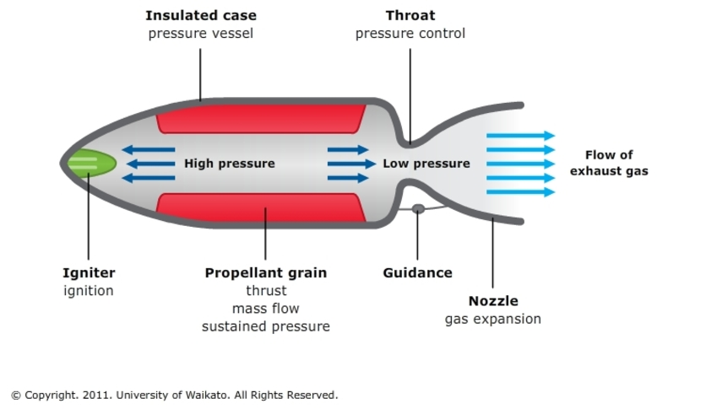
A typical rocket engine - This rocket engine shows how the chemical reaction of the fuel creates high pressure inside the combustion chamber. This pressure pushes the walls of the chamber forwards as gases are ejected
The pressure inside the combustion chamber pushes the gases out of this hole in one direction, and the rocket is pushed in the opposite direction. This same pressure also pushes forwards against the walls on the inside of the combustion chamber. (There is also some pressure pushing forwards against the inside walls of the expansion nozzle as the gases exit.)
This force that pushes a rocket is called thrust

