Getting Rockets into space
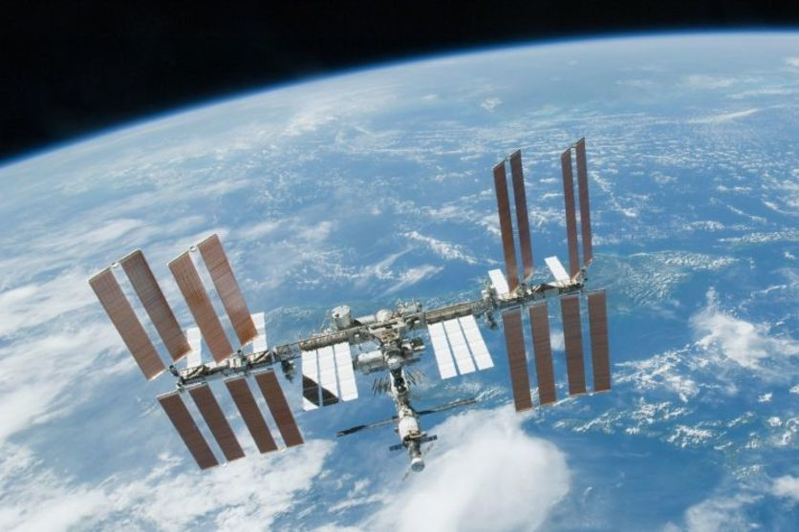
International Space Station
The International Space Station orbits the Earth at a height of about 360 km. It travels at 28 000 km/h and takes 90 minutes for each orbit.
Rockets launched into space can be suborbital (brief visit to space) or orbital (staying in motion around the Earth) or can escape Earth’s gravity to travel deeper into space.
  - What is space?
The official beginning of space is 100 km above the Earth’s surface. The gases that make up the Earth’s atmosphere thin out rapidly as height increases. If you were in a rocket travelling upwards, at a height of 11 km, you would have passed 77.5% of the Earth’s atmosphere. At 31 km, you would have passed 99%. At this height, you would see the blackness of space above you rather than the blue of the sky.
  - Gravity and space
The Earth is a massive object (6 x 1024 kg), and its gravitational influence extends well into space. The gravitational influence of Earth changes only a little for heights at which most low Earth orbit (LEO) satellites and the International Space Station operate.
At a height of 1000 km above the Earth’s surface, the gravitational force on a 10 kg mass is about 75% of its value on Earth.
This means that, even if a rocket reaches space, the force of gravity will still pull it back towards the Earth.
  - Suborbital rockets – visiting space briefly
Rockets that reach space and then return to Earth are classed as suborbital rockets. They are usually sounding rockets (‘sounding’ refers to taking measurements).
Sounding rockets are designed to take measurements of the atmosphere or to perform microgravity experiments as they travel up through the atmosphere and then fall back to Earth.
Sounding rockets can travel much higher than weather balloons (another way of measuring the atmosphere), which can only travel up to an altitude of 40 km. Some sounding rockets travel up to 950 km or higher before falling back to Earth.
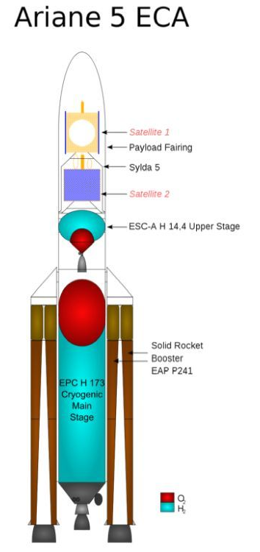
Ariane 5
Ariane 5 is a European Space Agency and Arianespace rocket used to launch satellites. It is 50 m tall with two stages. It is designed to carry two satellites into orbit
  - Getting rockets into orbit
To get rockets into orbit, they need much more thrust than the amount that will get them up to the required altitude. They also need sufficient thrust to allow them to travel with very high orbital speed.
For example, the International Space Station (ISS) is at an altitude of about 360 km. To build the ISS, each rocket carrying people and parts needed enough thrust to give it an orbital speed of 28 000 km/h. At this speed, an object at that height will stay in orbit around the Earth. If speed is less than this, an object will fall back to the Earth.
To help visualise this, Newton imagined a cannon placed on a very high mountain. If the cannon ball is fired with enough speed, it will travel so fast that it falls towards the Earth but misses it entirely. This is what satellites are doing.
There are approximately 3000 man-made satellites orbiting the Earth. Each of these has been placed into orbit by a rocket. Some are as big as a washing machine, some as big as a bus, and the International Space Station is as roomy as a 5-bedroom house and, with its solar panels extended, is the size of a rugby field.
  - Getting deeper into space
To travel beyond the Earth towards other planets and beyond, very large multistage rockets are needed to give a probe such as Voyager 1 enough thrust to escape the gravitational pull of the Earth and the Sun.
Voyager 1 is a 722 kg space probe that was launched in 1976 on a tour of the Solar System. More than 30 years later, it continues to transmit data and to travel into interstellar space.
In March 2004, the European Space Agency (ESA) launched the Rosetta spacecraft from Earth. It then took Rosetta 10 years to catch Comet 67P, where it then landed a probe.
Recent NASA launches have included the Juno mission on 5 August 2011. Juno will take 5 years to reach Jupiter, having travelled a distance of 2800 million km

