Shopping List and costing

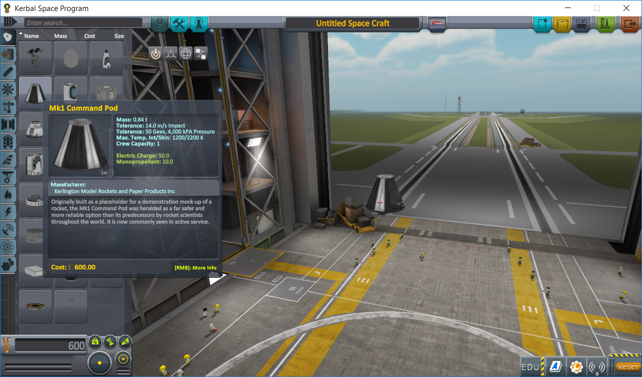
Part Cost
Using Kerbal look at the costings of a rocket design and document the materials this would use:
Part | Material | Costing

Total | £

