Lift-Off
A rocket will launch and keep speeding up as long as the force pushing it upwards (thrust) is greater than the forces pulling and pushing it downwards (gravity and drag).
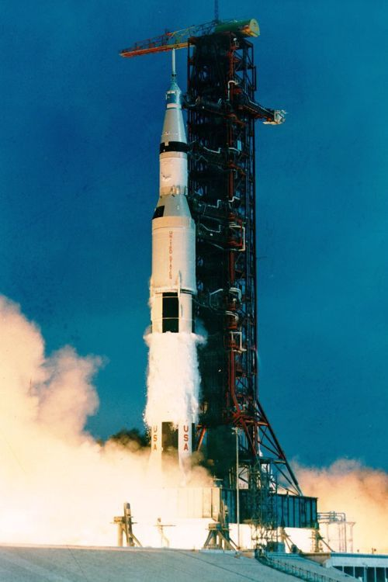
Apollo 11
Lift-off of the Apollo 11 on 16 July 1969. The 110 metre high Saturn V rocket carries three astronauts towards the Moon.
  - Newton’s first law
Newton’s first law helps us understand how forces get objects such as rockets moving.
An object at rest (not moving) will remain at rest unless acted on by an unbalanced force. Also, an object in motion will continue to move at a constant speed in a straight line unless acted on by an unbalanced force.
  - Balanced forces before lift-off
When a rocket is sitting on the launch pad and not moving, there are forces acting on it, but these forces are balanced. This means that the force pulling it downwards (gravity) is equal to the force pushing it upwards (support force of the ground). These forces are balanced. The rocket will keep on not moving, as described by Newton’s first law.
  - Unbalanced forces during lift-off
For an object to start moving, there needs to be an unbalanced force. This means that the forces pushing an object in one direction are greater than the forces pushing it in the opposite direction. The resultant force is the difference between the force(s) pushing in one direction and the force(s) pushing in the opposite direction.
There are two forces acting on a rocket at the moment of lift-off:
- Thrust pushes the rocket upwards by pushing gases downwards in the opposite direction.
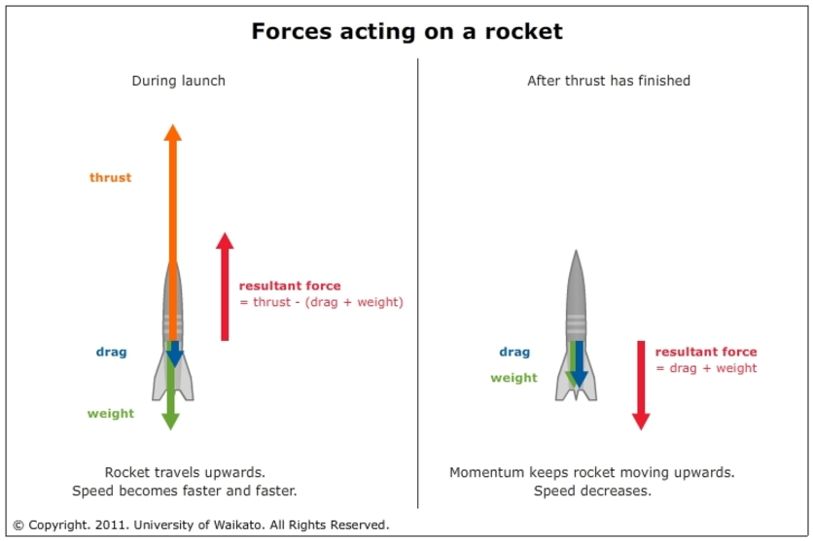
- Weight is the force due to gravity pulling the rocket downwards towards the centre of the Earth. For every kilogram of mass, there is 9.8 newtons (N) of weight.
As the rocket increases speed, there is a third force of drag that begins to increase. The resultant force is the sum of these individual forces.
Rocket forces
A rocket has three main forces acting on it during lift-off. The resultant force is the sum of these. The rocket will speed up (or slow down) in the direction of the resultant force.

  - Thrust needs to be greater than weight
A rocket launches when the force of thrust pushing it upwards is greater than the weight force due to gravity downwards. This unbalanced force causes a rocket to accelerate upwards. A rocket will continue to speed up as long as there is a resultant force upwards caused by the thrust of the rocket engine.
As an example, think of a rocket with a mass of 10 kg. The force of gravity pulling it downwards is 10 x 9.8, which equals 98 N. To get the rocket off the launch pad, the thrust must be greater than 98 N. For example, if the thrust is 120 N, the resultant force is 120 – 98 = 22 N upwards.
  - Momentum keeps things moving
Once the thrust from the rocket engines finishes, the resultant force is now downwards. A suborbital rocket will keep moving upwards because of its momentum, but it will slow down until it momentarily stops and falls back to Earth
  - The launch of a rocket to the Moon
The Apollo 11 mission to the moon was launched in 1969 by a Saturn V (pronounced ‘Saturn five’) rocket. The height of the rocket was 111 metres (longer than a rugby field). The diameter at the widest part was over 10 m (about the length of a classroom). The total mass of the rocket was 2,923,387 kilograms (nearly 3000 tonnes!), which is about the same as the mass of 417 school buses.
To launch this enormous rocket off the ground, NASA used five F-1 rocket engines, the most powerful rocket engines ever flown. The thrust needed to be greater than the weight force of nearly 28,700,000 N. The engines produced a thrust at lift-off of 33,400,000 N (enough to lift487 school buses!).
This means that the resultant force was about 5,300,000 N upwards.
  - G-forces acting on the astronauts
The g-force is a measure of how much force acts on a person or an object compared with the normal weight force due to the Earth’s gravity. To calculate g-force, divide the resultant force by the weight. This means that, at lift-off, the Apollo astronauts experienced 1.8 g, nearly twice the normal force due to gravity (5,300,000 divided by 2,923,387). This increased to a maximum value of 4 g as the mass of the rocket decreased.

