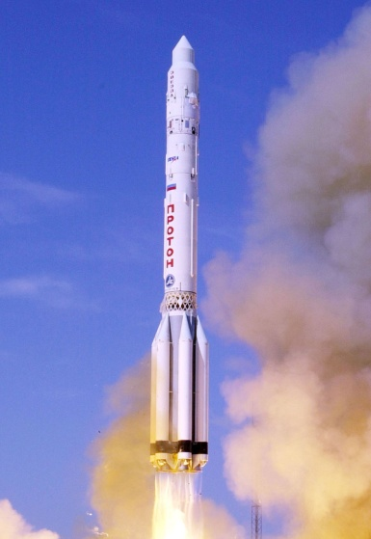
What materials are needed to build a rocket?

Think about what materials you would need in order to build your own rocket.
Use the space below to answer this question with images/diagrams and descriptions

