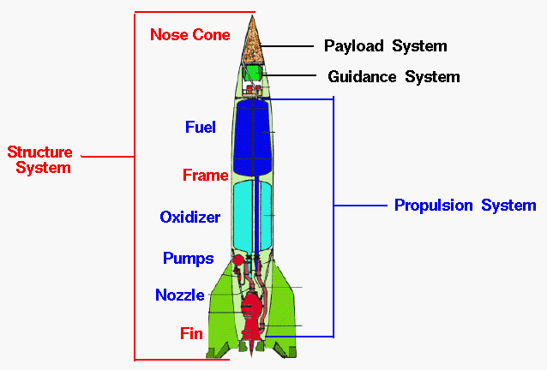
Using the labels put the rocket parts in the right place
Fuel | Frame | Oxidizer | Guidance system | Nozzle | Propulsion system
Nose Cone | Fin | Structure System | Payload system | Pumps

