# What shape is a rocket? Does this change?

Research the different rockets launched and what affect the different shapes had and what you thought of them.

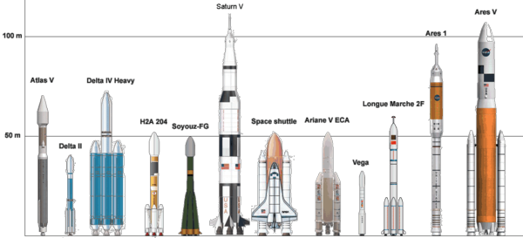

|  |  |  |  |  |  |  |
| --- | --- | --- | --- | --- | --- | --- |
| Rocket picture | Name of Rocket and if it is a manned rocket | What was the mission? | When was it launched? | Was it a successful Launch? | What do you think of the design? | What parts might you use in your designs? |
|  |  |  |  |  |  |  |
|  |  |  |  |  |  |  |
|  |  |  |  |  |  |  |
|  |  |  |  |  |  |  |
|  |  |  |  |  |  |  |
|  |  |  |  |  |  |  |