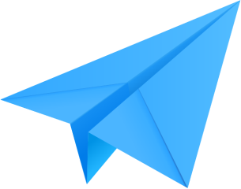

Paper Aeroplanes
  - Learning Objectives:
- To consider how design can affect the flight
- To understand how forces affect a paper aeroplane
- To test and gather data from a flight effectively

  - Which design have you chosen?
  - Why have you chosen this design?
  - What are your predictions for the flight?

Flight tests

- Flight Number | - Flight descriptions | - Flight Data | - Improvements made following flight

  - What materials did you use?
  - What affected the flight?
  - What would you improve if asked to start again?

