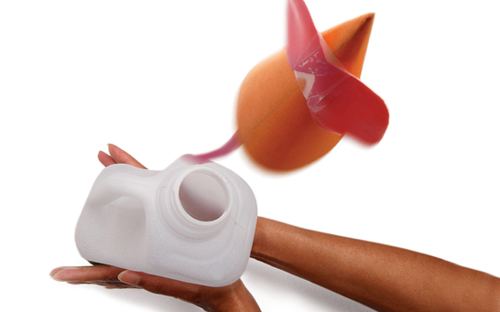

Rocket Mice
  - Using the table below document your launches
- Test Number | - Description of thrust applied | - Height achieved (cm)

What have you learnt from this activity?

