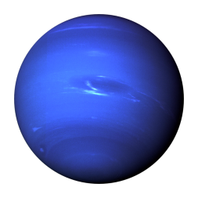
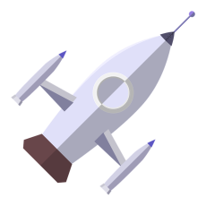
Rocket Parts
HWK 2

Research the different parts of a rocket and draw/stick in and label the key parts of a rocket:

Nose Cone | Payload Section | Transition Section | Shock Cord Mount | Shock Cord | Parachute | Shroud Lines
Body Tube | Launch Lug | Fins | Engine Block | Rocket Engine | Igniter | Recovery Wadding

