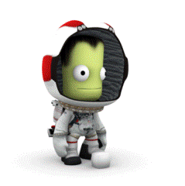

Kerbal – Missions

Now that you have launched a rocket there are a number of missions built into Kerbal that will help you understand the software and use it fully.

You need to work through the missions and complete the worksheet with each one

Mission 1
This mission will focus on introducing you to the basic game concepts and ﬂight mechanics. Playing the mission, you will learn to control vessels in KerbalEdu during ﬂight, take oﬀ and landing. You will do this by using historic planes.
  - What is the mission?
  - Did you succeed?
- Which of these did you use?  - (tick or highlight achieved) | - Steering & orientation  - Take oﬀ & landing on runway  - Flying in atmosphere  - Time warp  - Force arrows
  - What went well?
  - What have you learnt?
  - What concepts were used?

Mission 2
This mission introduces you to Kerbals, the green would-be-spacefarers that inhabit the planet of Kerbin. While learning the basic game concepts, you will also get to know physics phenomenon along the way, familiarising yourselves with constant speed, acceleration and Newton's second law.
  - What is the mission?
  - Did you succeed?
- Which of these did you use?  - (tick or highlight achieved) | - Using engines: adjusting thrust  - Diﬀerent types of fuels
  - What went well?
  - What have you learnt?
  - What concepts were used?

Mission 3
This mission will introduce you to the basics of vehicle construction and rocket design. You assemble diﬀerent vessels to test how diﬀerent qualities aﬀect physics phenomena - Newton's Second Law of Motion and work. In the course of the mission you need to formulate and test theories and hypotheses to solve the problems.
  - What is the mission?
  - Did you succeed?
- Which of these did you use?  - (tick or highlight achieved) | - Take oﬀ from launch pad  - Assembly: Linear attachment
  - What went well?
  - What have you learnt?
  - What concepts were used?

Mission 4
This physics-oriented mission will focus on diﬀerent forms of energy. It will also introduce you to a methodology of solving problems in the game by testing various theories to see if they hold up. You will build your own rockets for testing, continuing to learn about rocket assembly in the process.
  - What is the mission?
  - Did you succeed?
- Which of these did you use?  - (tick or highlight achieved) | - Assembly: Linear attachment  - Use of Flight Recorder
  - What went well?
  - What have you learnt?
  - What concepts were used?

Mission 5
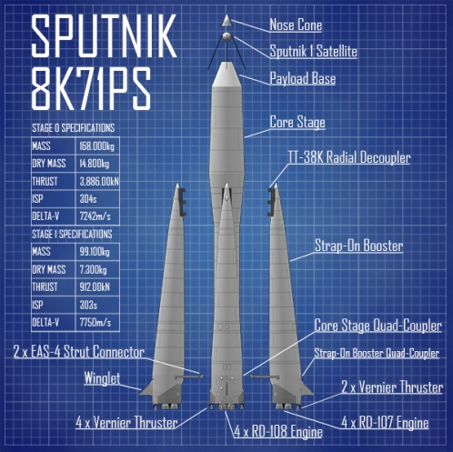
One of the rudimentary skills of space ﬂight is orbiting. Orbiting allows satellites to function and acts as the initial stage for moon ﬂights.
In this mission, you will use blueprints to assemble an R-7 rocket to carry Sputnik I back to orbit.
You will learn about diﬀerent directions on the navball and rudimentary ways to modify your orbits.
You will also tackle a more challenging building task with the R-7. The mission will also oﬀer the possibility to learn about potential and kinetic energy and reference frame on orbit.
  - What is the mission?
  - Did you succeed?
- Which of these did you use?  - (tick or highlight achieved) | - Staging  - Navball markers  - Orbiting
  - What went well?
  - What have you learnt?
  - What concepts were used?

Mission 6
Juri Gagarin was the ﬁrst human in space 1961. Now it's your turn to guide the Kerbals on their ﬁrst manned orbital ﬂight. Assemble your own spacecraft and follow in the footsteps of Vostok's ﬂight around the planet to learn about changing orbits and re-entry.
In this mission, you have more freedom over the make of your spacecraft and the course of your ﬂight, preparing you for more independent missions in the future.
In the process, you can compare your experiences and progress with Gagarin's ﬂight in 1961 - what diﬀerences and what similarities are there?
  - What is the mission?
  - Did you succeed?
- Which of these did you use?  - (tick or highlight achieved) | - Loading and merging spacecraft  - Navball markers  - Manoeuvering in the orbit
  - What went well?
  - What have you learnt?
  - What concepts were used?

